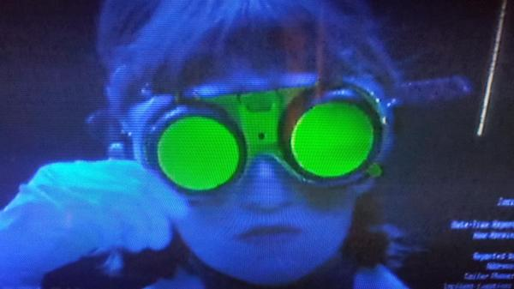
SCIENCE FORENSIC VIDEO
FORENSIC FILES - SANDS OF CRIME

NAME - ___________________________________________

Directions: Watch the video to complete the worksheet. Questions go in order. [Season 13, Episode 13]

1) Why was a 9-1-1 call originally placed at the start of this case? _____________________________________________

____________________________________________________________________________________________

2) Explain three facts about the victim’s body and/or crime scene where she was found.

1 - _________________________________________________________________________________________

2 - _________________________________________________________________________________________

3 - _________________________________________________________________________________________

3) What were two details about the victim’s car that were unusual?

1 - _________________________________________________________________________________________

2 - _________________________________________________________________________________________

4) What brand of shoe matched footprints at the crime scene? ________________________________________________

5) What was the official cause of death in this case? ________________________________________________________

6) Explain what a disassociated witness is? _______________________________________________________________

____________________________________________________________________________________________

7) How long after the murder did police receive a lead about a prime suspect? How did police get this lead?

____________________________________________________________________________________________

8) Why was this prime suspect ruled out? ________________________________________________________________

9) Explain what a DNA Dragnet is? How many total people were tested? _______________________________________

____________________________________________________________________________________________

10) How did police find a new prime suspect in this case? How long after the murder did this break happen?

____________________________________________________________________________________________

11) Explain two ways that police began to match their new prime suspect to the victim’s murder?

1 - _________________________________________________________________________________________

2 - _________________________________________________________________________________________
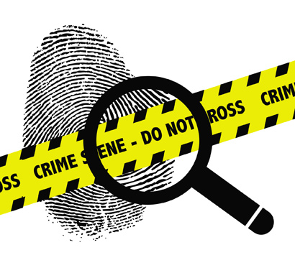
12) What piece of evidence was found at the prime suspect’s home? ___________________________________________

13) How was the killer matched to the crime? _____________________________________________________________

14) What sentence and conviction did the killer in this crime receive? _________________________________

___________________________________________________________________________________
VIDEO FOLLOW-UP WRITING
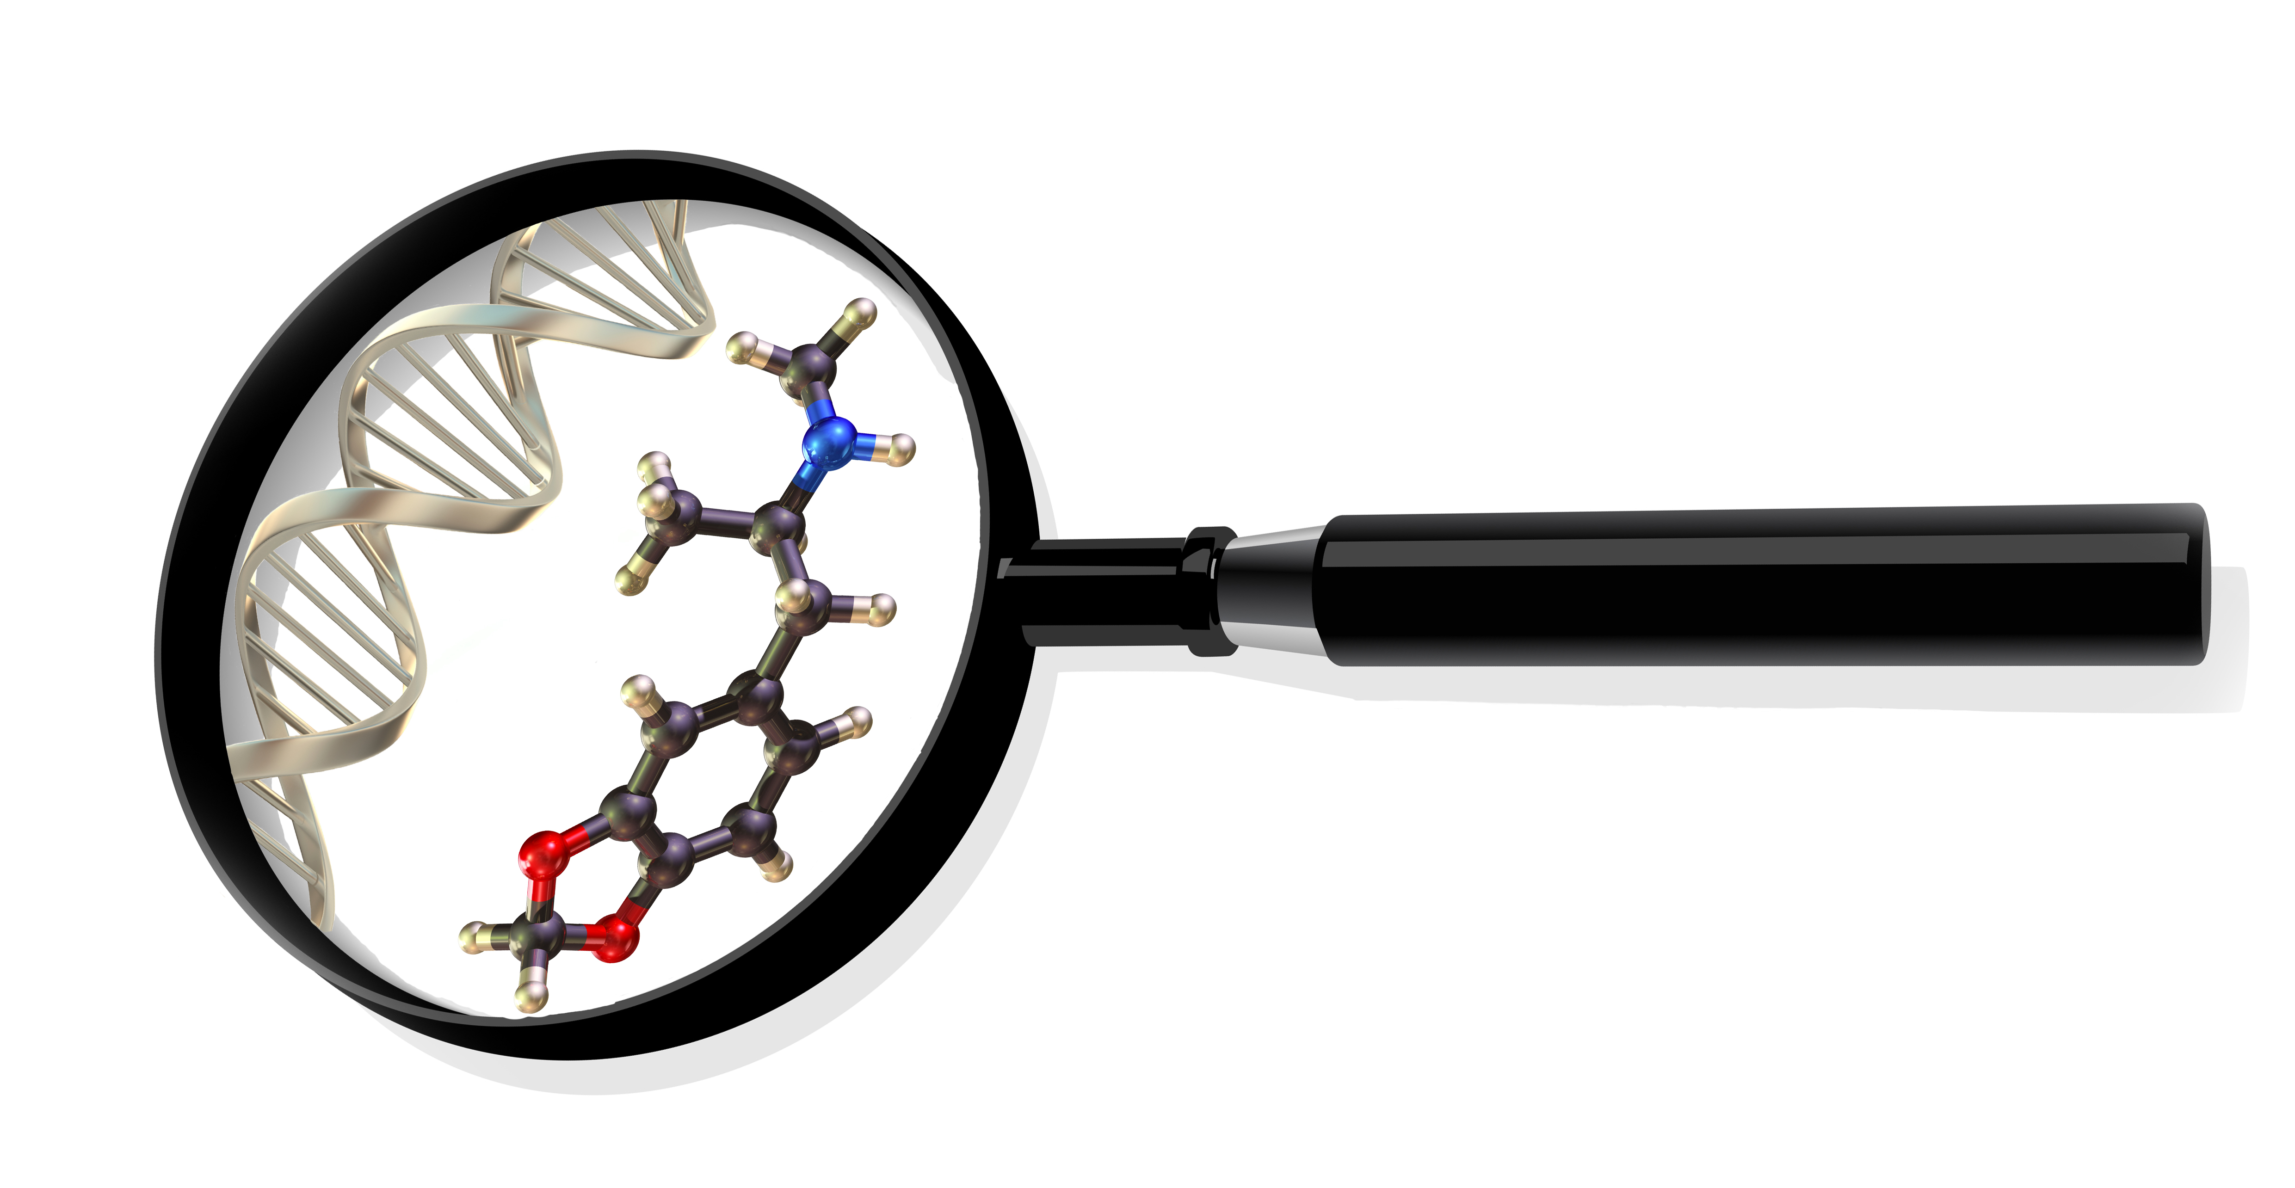
SEQUENCE
In order explain five key points in this case that lead to the killer’s conviction.

_________________________________________________________________________________

_______________________________________________________________________________________

_______________________________________________________________________________________

_______________________________________________________________________________________

_______________________________________________________________________________________

_______________________________________________________________________________________

_______________________________________________________________________________________

_______________________________________________________________________________________

_______________________________________________________________________________________

_______________________________________________________________________________________

_______________________________________________________________________________________

_______________________________________________________________________________________

_______________________________________________________________________________________

PROBLEM / SOLUTION
Explain a problem police faced in this case and how forensic experts helped solve it.

_________________________________________________________________________________

_______________________________________________________________________________________

_______________________________________________________________________________________

_______________________________________________________________________________________

_______________________________________________________________________________________

_______________________________________________________________________________________

_______________________________________________________________________________________








