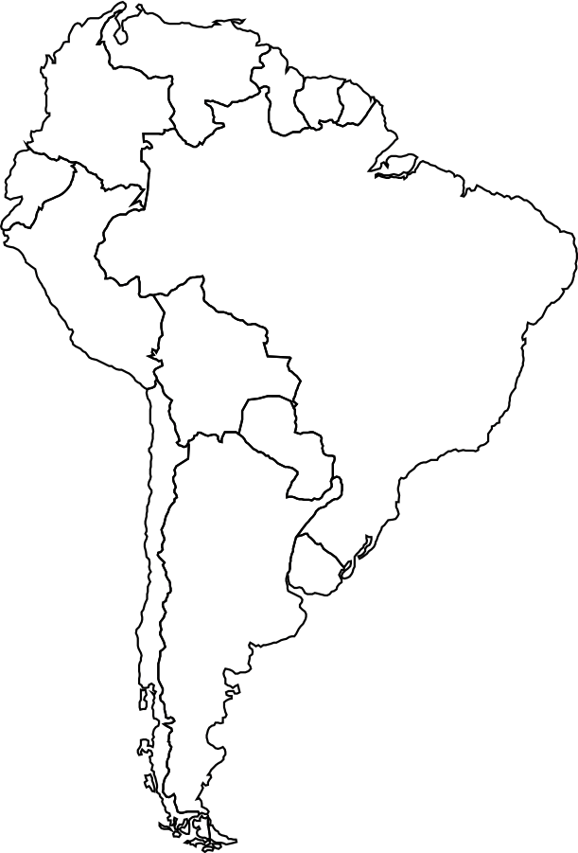

1. Argentina
2. Bolivia
3. Brazil
4. Chile
5. Colombia
6. Ecuador
7. Guyana
8. Paraguay
9. Peru
10. Surinam
11. Uruguay
12. Venezuela

Label the correct country name (letter) on the map

Name: ___________________________