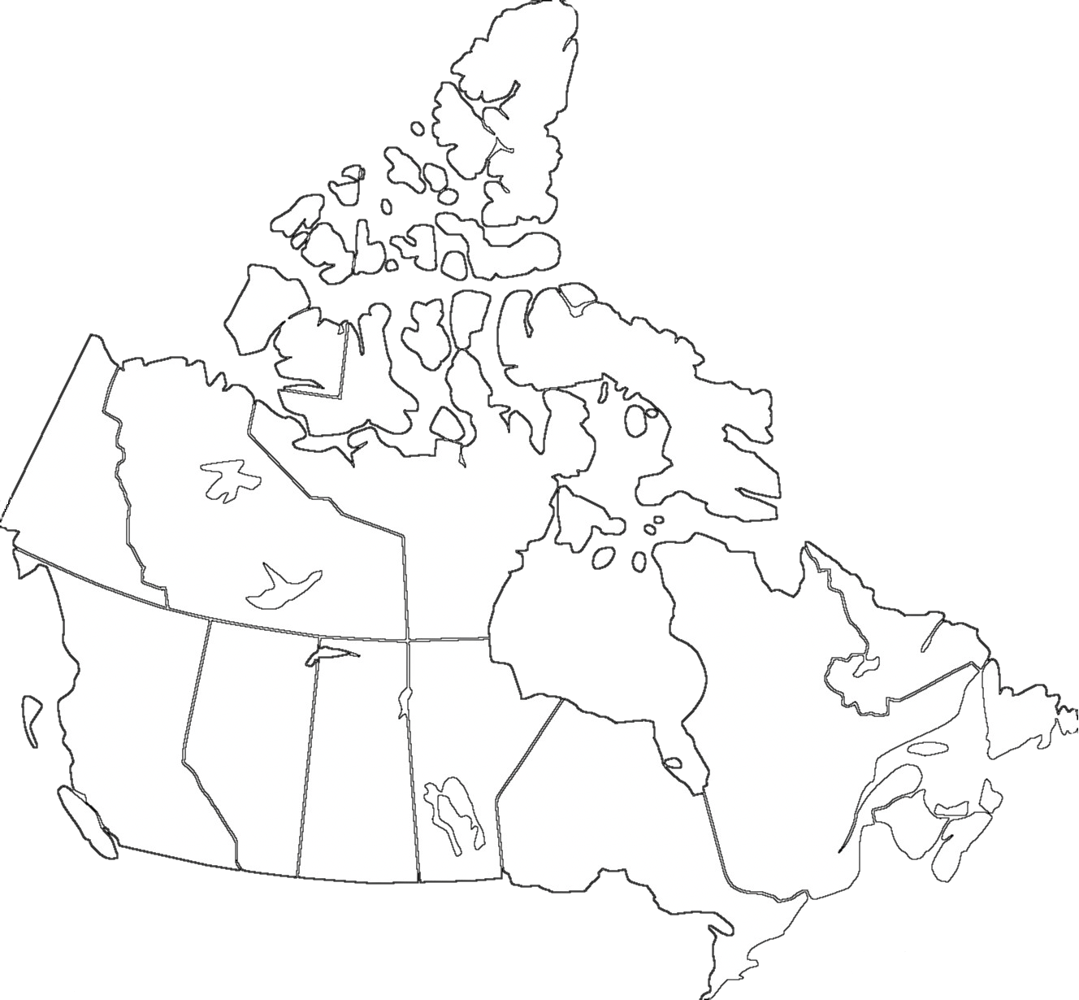

Name: __________________________

1. Ontario
2. Quebec
3. British Columbia
4. Alberta
5. Manitoba
6. Saskatchewan
7. Nova Scotia
8. New Brunswick
9. Newfoundland and Labrador
10. Prince Edward Island
11. Northwest Territories
12. Yukon
13. Nunavut