

1. Belize
2. Costa Rica
3. El Salvador
4. Guatemala,
5. Honduras
6. Nicaragua
7. Panama

Label the correct country name (letter) on the map.

Separate map for Caribbean Below!

Name: ___________________________

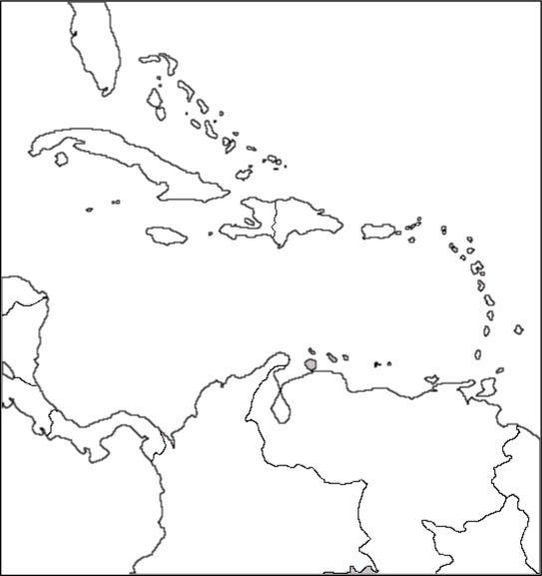

Label the correct country name (letter) on the map.

H. Cuba

I. Jamaica

J. Puerto Rico

K. Haiti

L. Dominican Republic