A Guide to Checks

For each 'boxed' number on the check below, you'll find a short description.
1. Personal information about the account owner
2. Payee line. Who the check is payable to - (print)
3. The dollar box. The amount of the check in numerical format
4. The amount of your check written out using words instead of numbers (print)
5. Memo line for an unofficial note
6. Date line
7. Signature line (cursive)
8. Your bank’s contact information and/or logo
9. Your bank's routing number (each bank has a different number)
10. Your account number at your bank
11. Check number (note that this appears in two places)
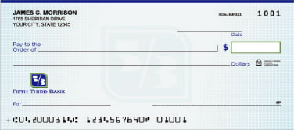
11
11
10
9
8
7
6
5
4
3
2
1

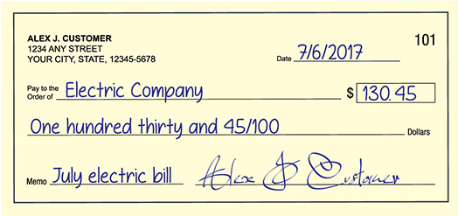

1. Is this a business or personal check? _________________________________
How do you know? _____________________________________________
2. What is the amount of the check? ___________________________________
3. Who is the 'owner' of this checking account? __________________________
4. What is the check number? _________________
5. Who is the check written to? ________________________________________
6. What date was this check written? ___________________________________
7. If the Electric Company tried to cash this check today, would they be allowed? Yes or No (circle one)
Why or why not? ______________________________________________

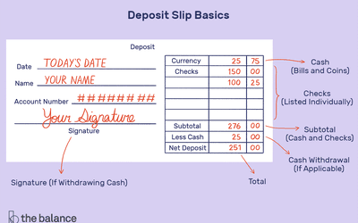

1. How many checks is this person depositing? ___________________
2. What is/are the amount of the check(s) being deposited? ______________________________________________________
3. How much 'cash' is this person depositing? _____________________
4. How much cash back does this person want? ____________________
5. How much will be deposited into this person's checking account? __________________________
6. If this person did NOT want cash back, would they still sign the deposit slip/ticket? Yes or No (circle one)

