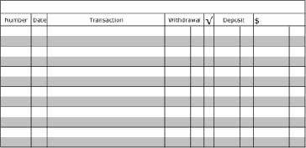
Recording and Balancing a Check Register - #2
- The beginning balance is $200.00
- Check #407 to Bridgepoint Church for $30.00 on November 1, 2019
- Debit card purchase at Starbucks for $15.73 on November 2, 2019
- ATM withdrawal of $15.00 on November 3, 2019
- Deposit of $40.00 on November 4, 2019
- Debit card purchase at Sky-Zone for $35 for birthday gift on November 4, 2019

