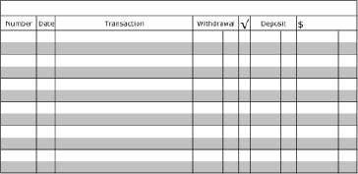
Recording and Balancing a Check Register

- The beginning balance is $208.04
- Check #312 to Panera for $18.45 on October 21, 2019
- Debit card purchase at Target for $39.45 on October 22, 2019
- ATM withdrawal of $20.00 on October 23, 2019
- Deposit of $108.50 on October 24, 2019

