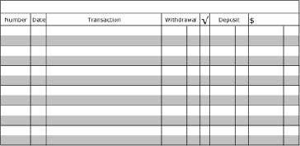
Recording and Balancing a Check Register - #4
- The beginning balance is $1345.66
- ATM withdrawal of $350.00 on November 12, 2019
- Debit card purchase at Movies 10 for $45.83 on November 13, 2019
- Deposit $60 on November 14, 2019
- Check #618 to Sammy for $81.93 on November 15, 2019
- Check #619 to Publix for $34.58 on November 16, 2019
- Transfer from checking to savings of $80.00 on November 17, 2019

