Want to find the best local food in town? Want to know how to ask where the train station is in the local language? It's all about the apps. All of these— will make your travels so. much. easier.

1. Roadtrippers
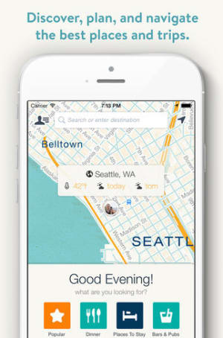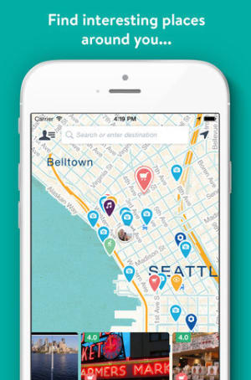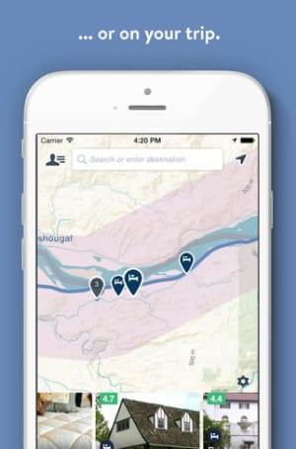

Roadtrippers is a must-have for anyone planning a road trip in the United States. You enter where you want to go, make selections depending on what you want to see (natural wonders! weird stuff!), and the app will create a customized map for you.
Download here.
Find other cool places to stop on your journey using AroundMe, iExit, and Field Trip.

2. Hotel Tonight
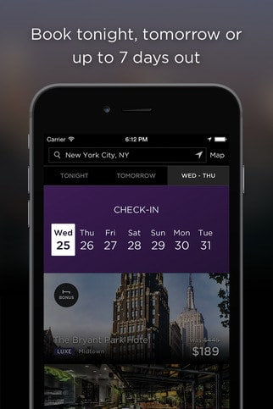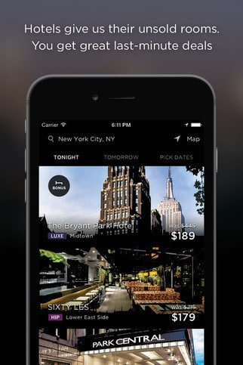
Get last-minute discounts on top-rated hotels using Hotel Tonight. You can only book a week in advance, so it’s not the best option for a long-planned family vacation…but for a fun, spur-of-the-moment getaway? Perfect.
Download here.
Another similar app to try: Roomlia.

3. Hopper
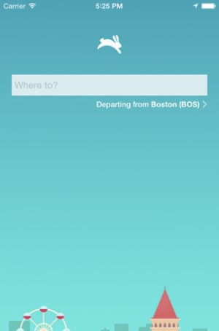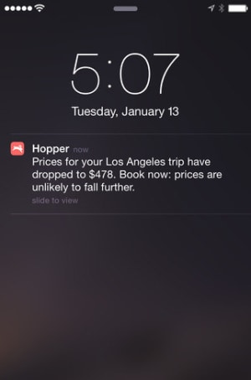
You’ll get your lowest airfares ever thanks to Hopper’s finely tuned price-prediction feature. First it figures out the best time for you fly, then it figures out the best time for you to buy tickets for that flight.
Download here.

4. Travel Math
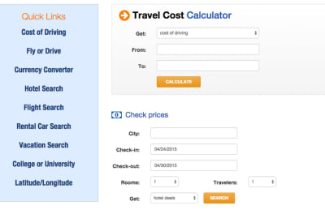
If your brain is frazzled at the mere idea of organizing a trip, let Travel Math do all the calculations for you: it'll measure distances, travel times, budgets--whatever you need to know.
Download here.

5. Ship Mate
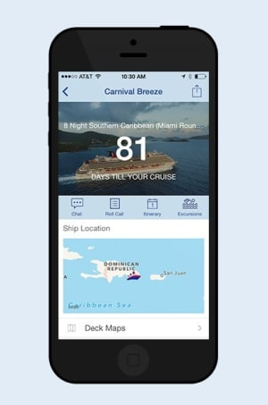

Cruise crazy? This is the #1 app when it comes to vacations taken on a ship. You can take a look at deck plans, read reviews of the different ports you'll be stopping at, chat with other people who will be on your ship, and more.
Download here.

6. CityMaps2Go
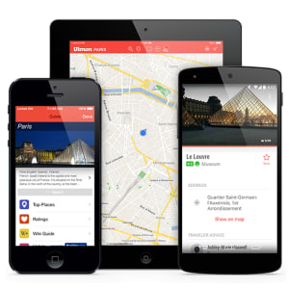

Studio Ghibli
If you're traveling outside your country and have to depend on Wi-Fi for internet, it's smart to download all the maps you'll need in advance at CityMaps2Go: they're stored offline, so you'll avoid roaming charges.
Download here.

7. Pack Point
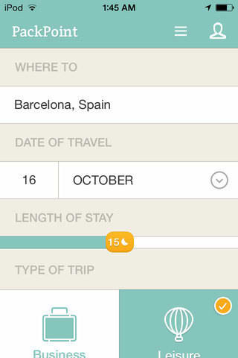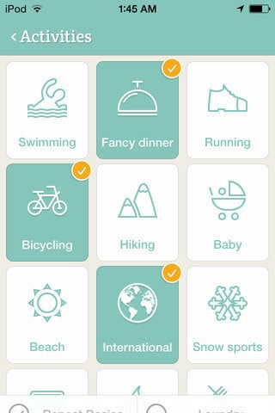

Pack Point helps you decide what to pack depending on where you're going, what the weather will be like, and what sort of activities you'll be participating in.
Download here.
Another similar option - Travel List.

8. Tripit
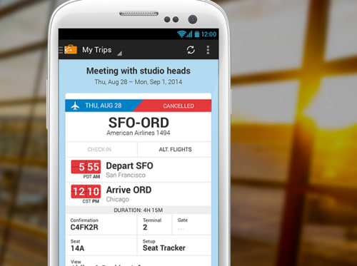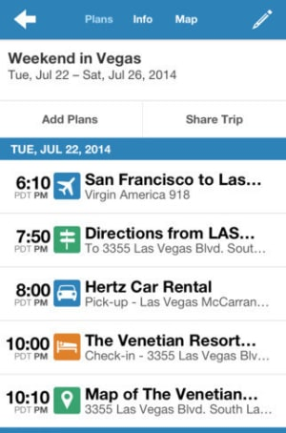
TripIt organizes all your travel itineraries and documents so you have everything in one place before you even get to your destination. Just have your reservations automatically sent to TripIt, which will let you view travel confirmations, flight itineraries, tickets, hotel and Airbnb booking info, rental car reservations, ferry tickets and driving directions in one easy place. The app also makes it simple to share your trip plans with whoever is picking you up from the airport or train station, as well as anyone else who may need to coordinate with you or know what your travel plans are.
Download here.
9. Roomer
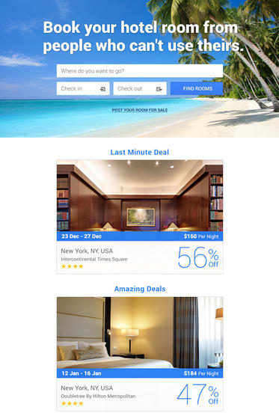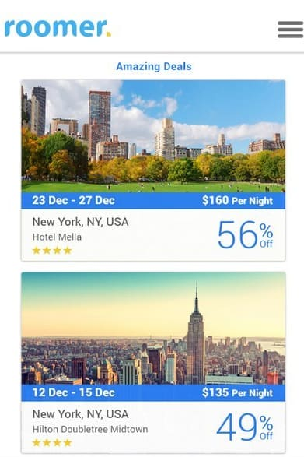
Your daughter is throwing up everywhere and suddenly going on vacation is no longer an option: What do you do about your hotel room? Get rid of it using Roomer. You list your room and wait to hear from someone who wants to take over your reservation — no more losing money on cancellation fees!
Download here.

10. Jet Lag Rooster
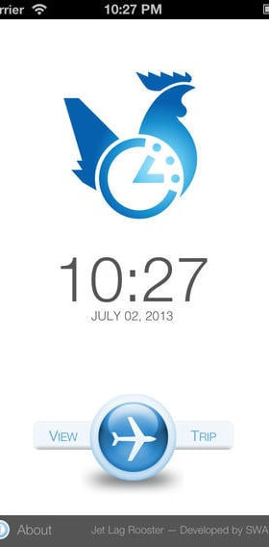
Jet Lag Rooster will tell you how to shift your sleeping schedule in the days before a trip so you won't be exhausted once you reach your destination.
Download here.
11. Dude Where's My Car?
The last thing you want to do when you get back from a trip is wander around the airport parking garage for 30 minutes, exasperatedly searching for your vehicle: Dude Where's My Car keeps track of *exactly* where you parked and will guide you back to that spot. Plus, it also helps you find parking.
Download here.

12. Loungebuddy
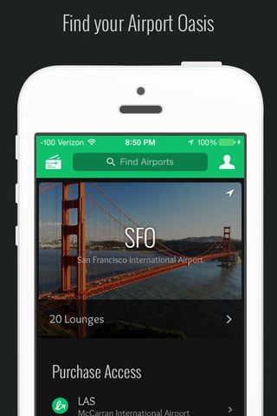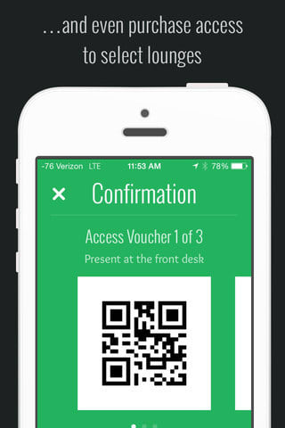
Did you know that you can use a ton of airport lounges even if you aren't a first class passenger? Sometimes it's worth paying a fee if it means getting to wait for your flight in a comfortable spot--Loungebuddy will let you know what your options are at the airport you're flying out of.
Download here.
13. My TSA
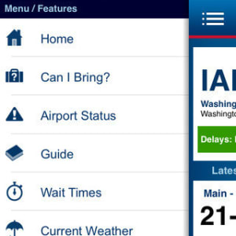
Can you bring _____ through airport security? Open up My TSA and you'll know in an instant. You can also use the app to look up how long the security wait times are at your airport so you'll be sure to arrive early enough to make your flight.
Download here.
For more help navigating an airport like a pro, take a look at GateGuru and Flight Aware.

14. Track My Tour
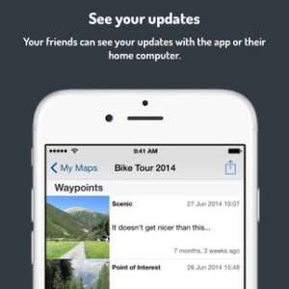
This app allows your loved ones to "join" you on a trip from the comfort of their homes: they "follow a breadcrumb trail of your tour by visiting the link you sent them," while you document the most exciting spots you visit as you go--it's the easiest way to keep people in the loop.
Download here.
15. Unlike
Put together your dream trip itinerary using the guides at Unlike, an app that "connects tastemakers and trendsetters around the globe with unique, essential and inspiring places."
Download here.
You should also check out 12hrs, Spotted By Locals, and Trover.

16. iTranslate
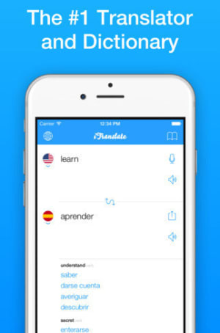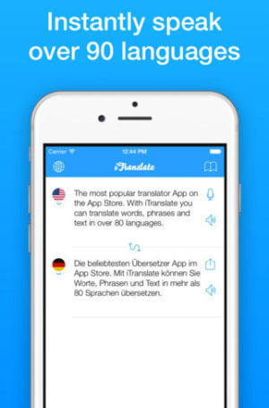
Providing you with "90+ languages in your pocket," iTranslate is one of the best translator apps available. If you're heading to the Netherlands and you can't speak Dutch, this is a necessity.
Download here.
Another awesome option = Trip Lingo.

17. City Papers
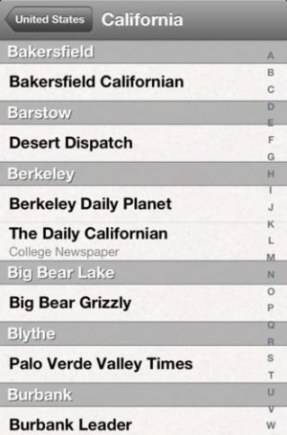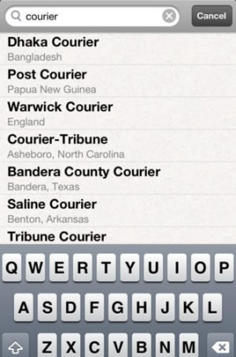
Find out what's happening in the city or town you're visiting using the collection of local newspapers available on the City Papers App: you'll be able to discover concerts, craft sales, and other events that may not even be listed online.
Download here.

18. Untappd
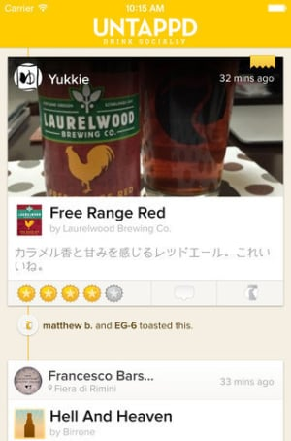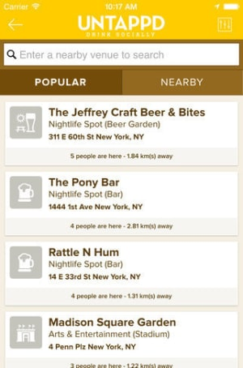
When you're in a new place (for work or on vacation), open up this app and it will give you a list of popular nearby bars *plus* what sorts of beer are on tap there. You want to to find someplace that serves a state-specific microbrew? This is how to hunt a glass of that down.
Download here.

19. TV Food Maps
If you're more interested in food tourism than beer tourism, take a gander at TV Food Maps: it's a guide to restaurants that are featured on popular TV series like Chopped and Diners, Drive-ins and Dives.
Download here.
For more dining recommendations, check out Flavour and Open Table.

20. Happy Cow
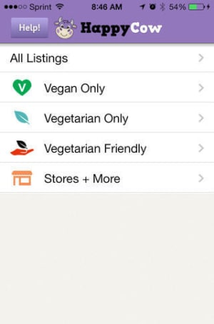
Depending on what part of the country (or world) you're in, it can be difficult to find vegan or vegetarian friendly restaurants: When you want some help with your search, browse through the listings on Happy Cow--you'll find dining establishments with meat-free options all over the world.
Download here.
21. LogMeIn
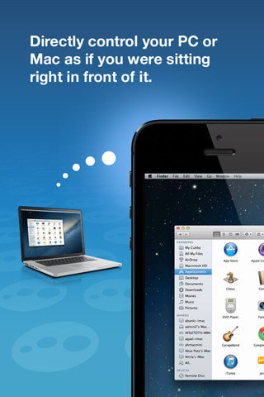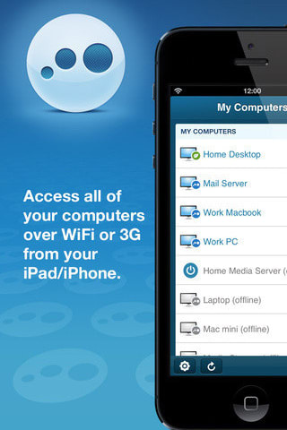
It's a horrible moment when you realize that you need a file stored on your home computer when you're 700 (or even just 30) miles away from it: LogMeIn allows you to access (and control) your home computer from anywhere.
Download here.

22. Vayable
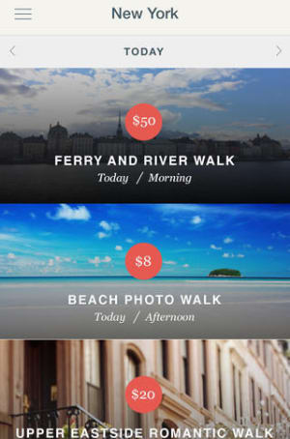
Vayable is a way to discover "unique experiences offered by locals" on your next trip. All of the available options sound so much cooler than traditional city tours: A midnight street food crawl! A guide to the most photogenic places in Paris! DIY seafood with a sea forager!
Download here.
23. My Disney Experience
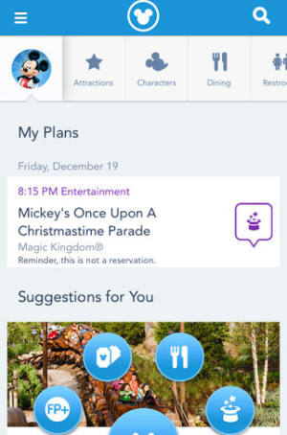
Don't enter the gates of the Magic Kingdom at Disney World without downloading this useful app. You can access real-time wait times, so keep checking to see how long the wait is at Splash Mountain and *SPRINT* over there when it says it's only 15 minutes. You can also make dining reservations, look up parade showtimes, and more.
Download here. If you're going to Disneyland, download this app instead.

24. Currency Converter
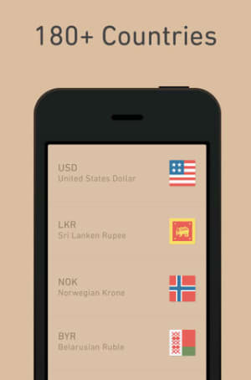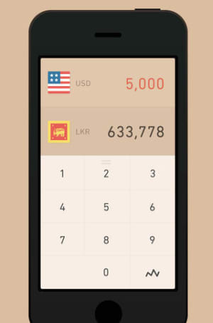
If you want a simple way to figure out how much a Euro equals in USD, use Currency Converter (it will do calculations for over 160 currencies from all over the world).
Download here.
25. Fancy Tips
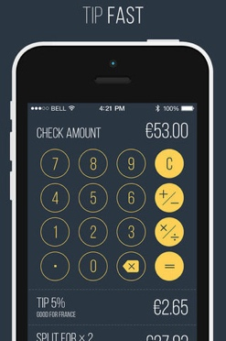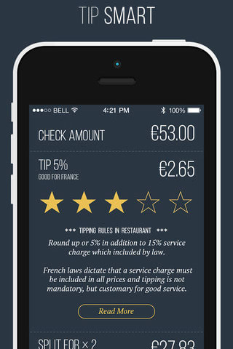
Don't piss off the local waiters and bellhops--check out Tip Fast to see what the typical tipping habits are in over 240 countries and regions.
Download here.

26. Wi-Fi Finder
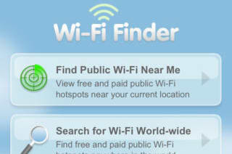
Use Wi-Fi Finder to find locations where you can use Wi-Fi for free. It works worldwide, so be sure to download it before your next trip to avoid being charged pricey roaming fees.
Download here.

27. Panoramio
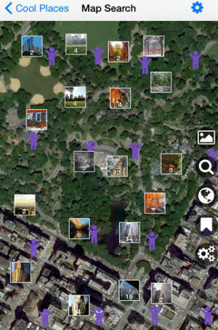
If you're going on a trip, you want to take some awesome pictures to make everyone who follows you on Instagram jealous--use the map function on Panoramio to easily find picturesque places to snap a few 'grams and let the likes roll in.
Download here.

28. Goldstar
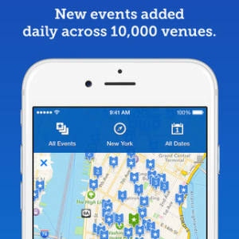
Find half-price tickets to live entertainment in cities all over the world (from concerts and musicals to comedy shows and sporting events).
Download here. If you're travelling to New York and you want to see a show on Broadway, try TodayTix.

29. Postagram
Have a technophobe friend or relative that doesn't really text or check their email? Do you just believe that snail mail is more special? Use Postagram to easily send photos from your vacation as actual postcards.
Download here.

Google Trips
Google Trips is out to give TripIt a run for its money. The app offers customized tours, guides and maps, and shows restaurants and/or monuments that are close to your hotel. Google Trips gathers all the travel information from your Gmail account, easily storing it offline so you’ll have access to it with or without Wi-Fi. Looking to travel lighter and save time? Consider using the app’s destination-based features as an alternative to lugging around a heavy guidebook or digging through a ton of emails to find your reservations.
Download: Android and iOS
Travel Resources:
TripAdvisor
Travelocity
Expedia
Orbitz

