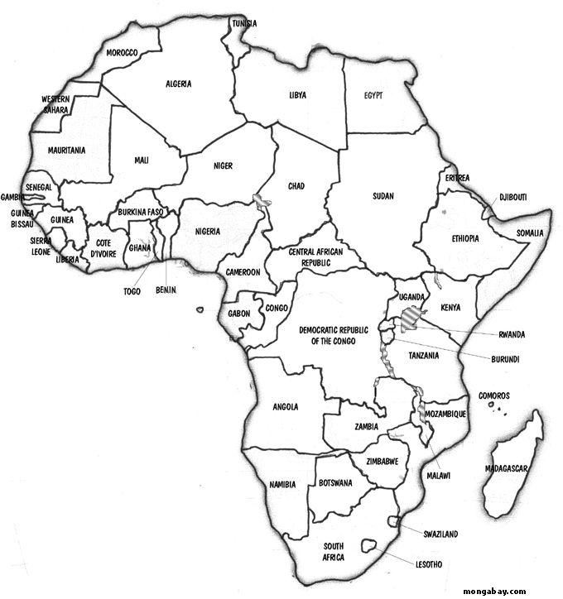

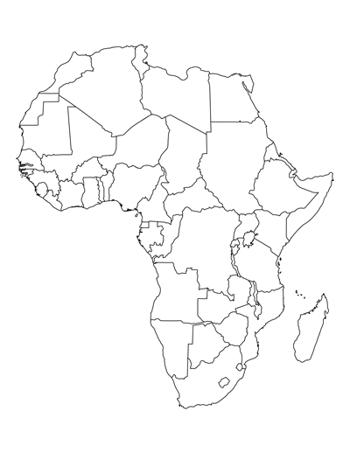

Monday, March 2:
Students should be prepared to take a quiz knowing the location of the following countries:

Algeria Egypt Morocco
Libya Tunisia Sudan
Chad Niger Mali
Ethiopia Djibouti Somalia
Nigeria Congo Central African Republic
Uganda Kenya Democratic Republic of the Congo
Tanzania

Students should have the following pages completed in their packet:
Algeria
Egypt
Morocco
Libya
Tunisia
Sudan
Chad
Niger
Mali

Monday, March 9:
Students should be prepared to take a quiz knowing the location of the following countries:

Algeria Egypt Morocco
Libya Tunisia Sudan
Chad Niger Mali
Ethiopia Djibouti Somalia
Nigeria Congo Central African Republic
Uganda Kenya Democratic Republic of the Congo
Tanzania Madagascar Rwanda
Zambia Angola Namibia
Botswana Zimbabwe Mozambique
Botswana South Africa

Students should have the following pages completed in their packet:

Algeria Egypt Morocco
Libya Tunisia Sudan
Chad Niger Mali
Ethiopia Djibouti Somalia
Nigeria Central African Republic Democratic Republic of the Congo
Congo Uganda Kenya
Tanzania

Monday, March 23:
Students should be prepared to take a quiz knowing the location of the following countries:

Algeria Egypt Morocco
Libya Tunisia Sudan
Chad Niger Mali
Ethiopia Djibouti Somalia
Nigeria Congo Central African Republic
Uganda Kenya Democratic Republic of the Congo
Tanzania Madagascar Rwanda
Zambia Angola Namibia
Botswana Zimbabwe Mozambique
Botswana South Africa Western Sahara
Mauritania Senegal Guinea
Liberia Cote D’Ivoire Ghana
Togo Cameroon Gabon

Students should have the following pages completed in their packet:

ALL Pages

