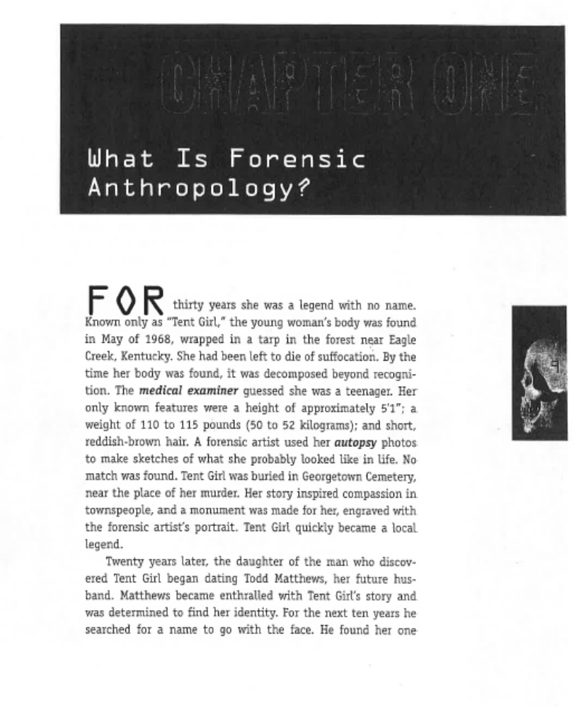
Name:_______________________________ Date:________________
What does the word autopsy mean in this sentence?

Key Words:

suffocation: killing by cutting off oxygen.
decomposed: breaking down

By: Angela Libal

Infer the reason why the young woman that died was known as “Tent Girl”.
The young woman that died was known as “Tent Girl” because_____________________
___________________________________________________________________________________________________________________
Determine how many years later the body was identified?
The body was identified by Todd Matthews _____________ years after the crime.

Describe the types of technology that could be used today to identify the body?
Today it is common for forensic anthropologists to use ______________
______________________________________________________________________________________________________________________________________________________________________________________________________________________________________________________________________________________________________________________________________________________________________________
Identify the meaning of the word “autopsy”.

Autopsy means______________________
____________________________________________________________________________________________________________
Key Words:

superimposed: placed over

Identify two things that the forensic anthropologist used to finally find the name of the young woman who died?

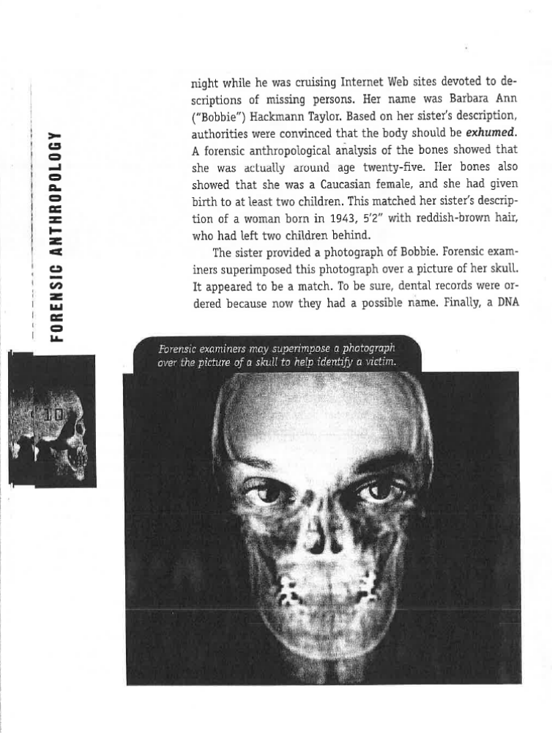

Identify the meaning of the word “exhumed”.
The word exhumed means___________________________________________________________________________________________________________

Distinguish whether or not the killer was found. Provide evidence to support your answer.
The killer ____________________________
__________________________________________________________________________
This is clear because according to the text it states___________________________________________________________________________________________________________
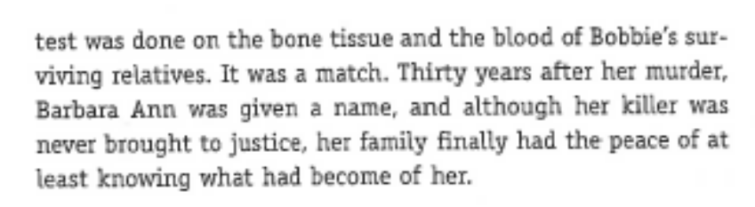

Identify whether or not the killer was found.

STOP—WHAT HAPPENED WHEN?!!!
Place the following events in the order in which they appear in the text.

______The young woman was identified as a 25 year old named
Barbara Ann.
______Todd Matthews worked hard to identify the body and used
the internet as a helpful tool for his search.
______The young woman’s body was found wrapped in a tarp in
the forest.

Key Words:
artifact: old object
disciplines: areas of information

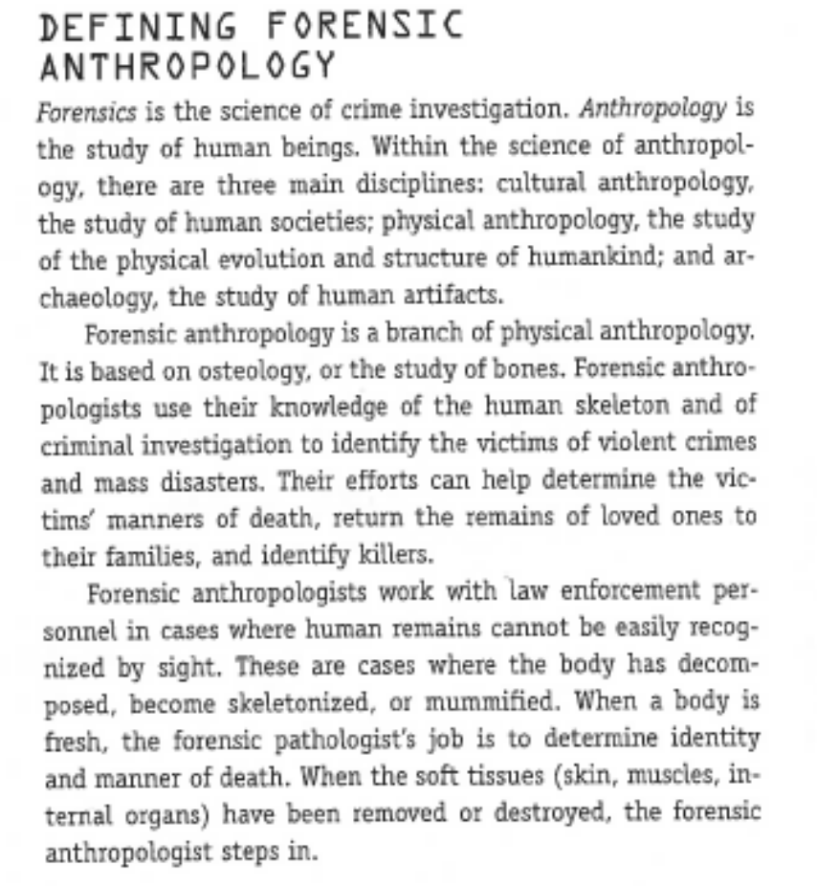
Identify the three main disciplines in forensic anthropology?
1.
2.
3.

Explain the role of a forensic anthropologist during a crime scene investigation?

________________________________________________________________________________________________________________________________________________________________________________________________________________________________________________________________________________________________________

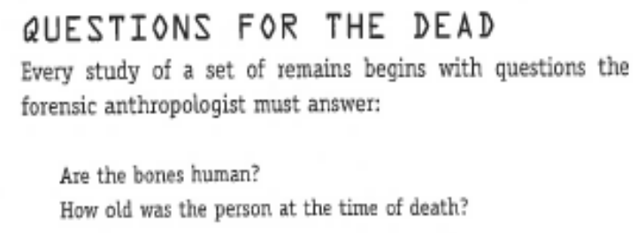
Key Words:

stature:body type; height, weight
anatomical: human body structure

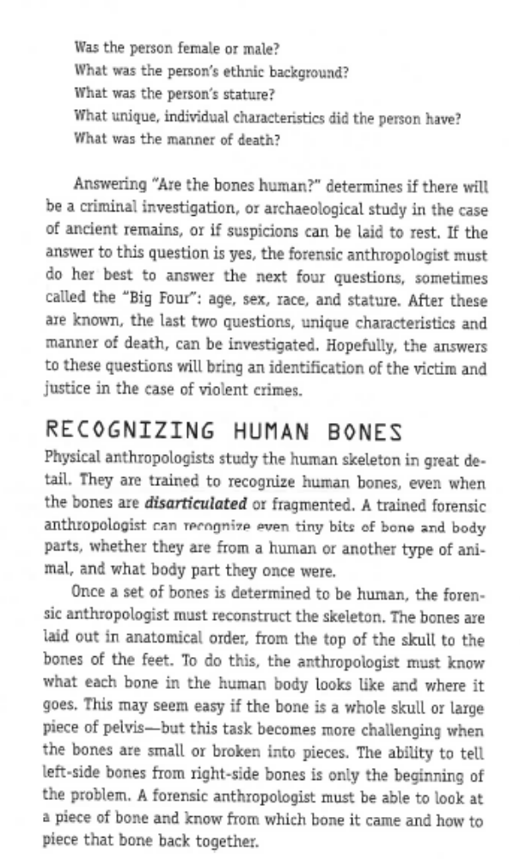

Explain why the heading for this section of the article is called “Questions For the Dead”.

The heading for this section of the article is titled “Questions for the Dead” because_______________________________
_______________________________________________________________________________________________________________

If an anthropologist discovers human bones, then they must ask the “Big Four” questions. Identify the questions below.
1.
2.
3.
4.

Fill in the following sentence:
In order to_________________________ the forensic anthropologist needs to know what each bone looks like and where it is located in the body.

Re-read the paragraph above and then identify the meaning of the word “disarticulated”.

The word disarticulate means_____________________________________________________________
_____________________________________________________________________________________

Key Words:

genocide: the intentional killing of a large
group of people
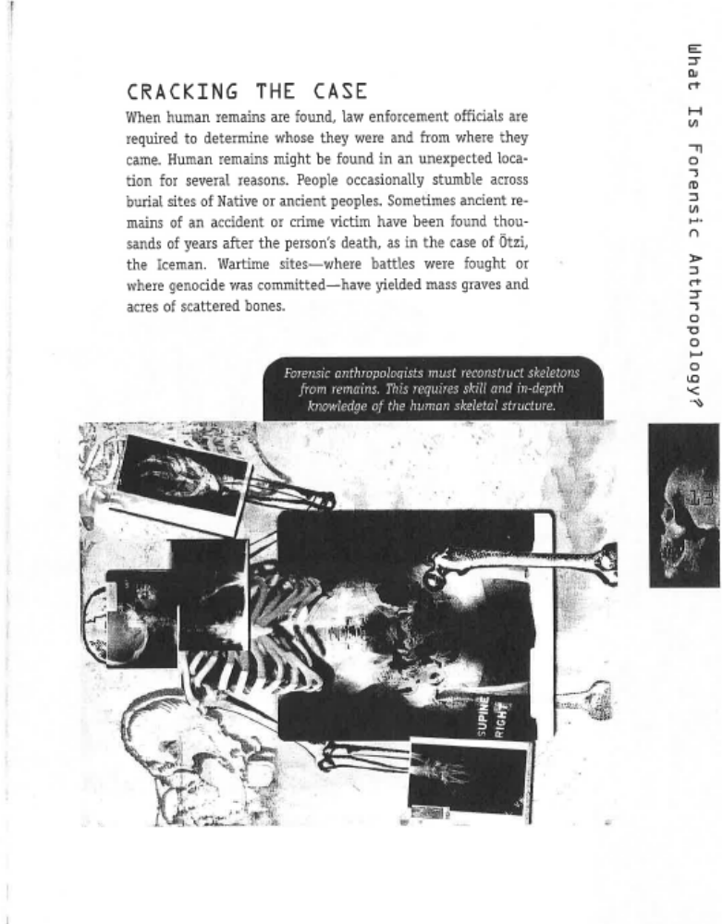
Describe one reason why human remains may be found at unexpected locations.

_________________________________________________________________________________________________________________________________________________________________________________________________________________________________________________________________________________________________________________________________________________

WOW!
LOOK WHAT A FORENSIC ANTHROPOLOGIST CAN DO!!!!

Describe the process above that forensic anthropologists complete in order to do their job.

____________________________________________________________________________________________________________________________________________________________________________________________________________________________________________________________________________________

Explain the purpose of this process.
____________________________________________________________________________________________________________________________________________________________________________________________________________________________________________________________________________________

Key Words:

intactness: not changed/not broken
consulted: discuss with

After reading the section of the article below, describe another reason why human remains may be found at unexpected locations.

___________________________________________________________________________________________________________________________________________________________________________________________________________________________________________________________________________________________________

Read before answering question above
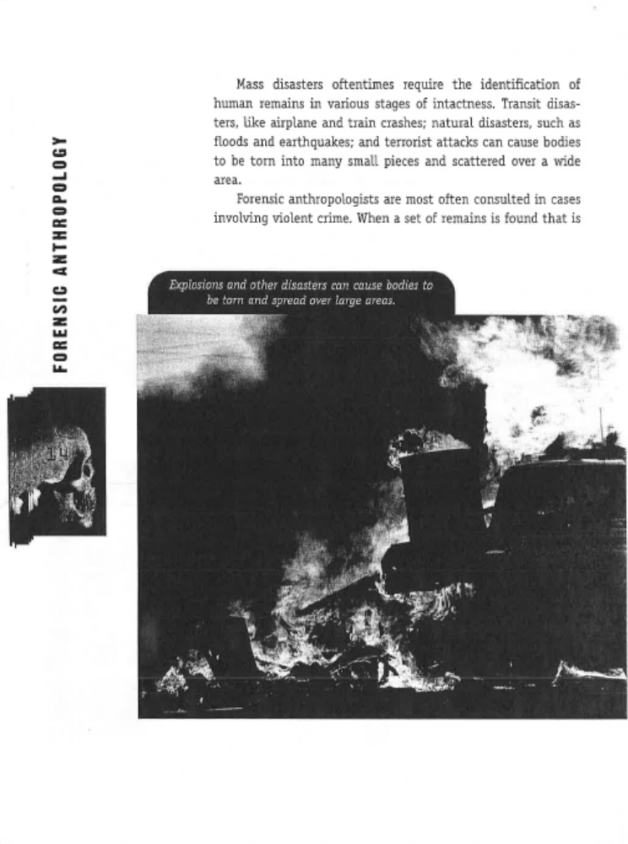

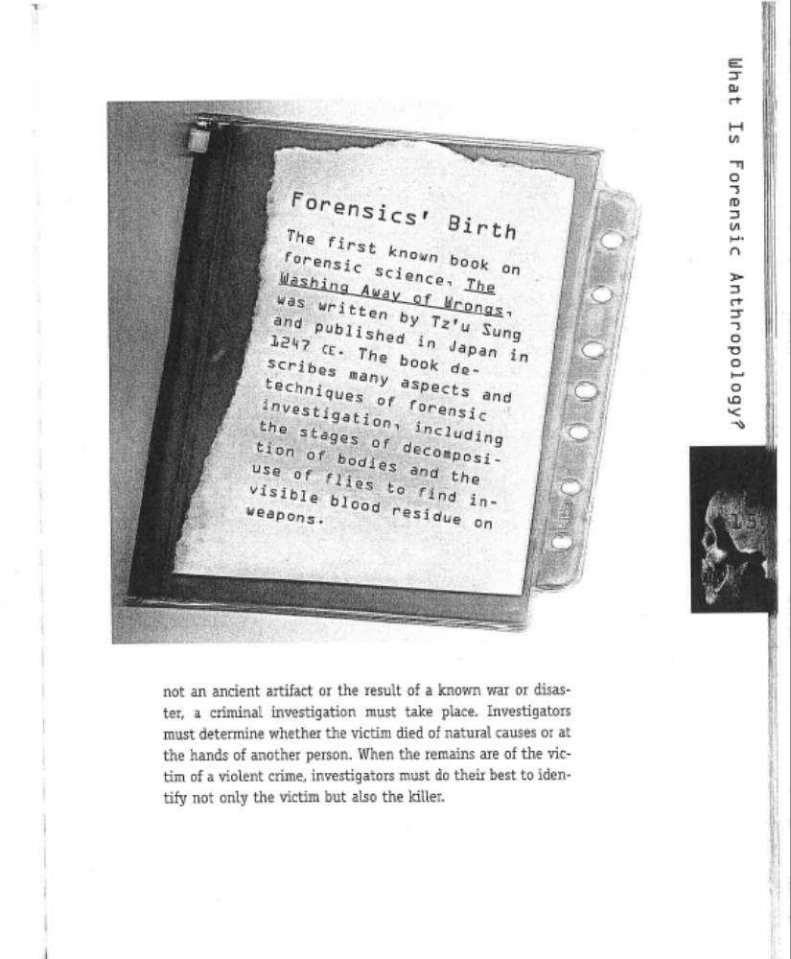

WOW!
THIS IS THE
THE FIRST BOOK ON FORENSIC SCIENCE!
In 1-2 sentences illustrate the significance of the book titled Forensics’ Birth. BE SURE TO TTQA!

__________________________________________________________________________________________________________________________________________________________________________________________________
__________________________________________________________________________________________________________________________________________________________________________________________________
Cite a direct quote that shows what investigators must determine.
Remember to use MLA Citation!

Classify the two people that the forensic anthropologist must identify if the crime is violent.

1.

2.

