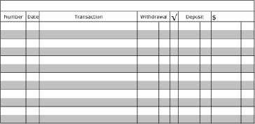
Recording and Balancing a Check Register - #3
- The beginning balance is $85.00
- Transfer from savings to checking of $75.00 on November 7, 2019
- Debit card purchase at Walmart for $14.71 on November 8, 2019
- Deposit check from grandma for $72 on November 9, 2019
- ATM withdrawal of $20.00 on November 10, 2019
- Check #506 to Trinity for $18.50 on November 11, 2019

