
SCIENCE FORENSIC VIDEO
FORENSIC FILES - BEATEN BY A HAIR

NAME - ___________________________________________

Directions: Watch the video to complete the worksheet. Questions go in order. [Season 3, Episode 9]


1) At first, what was one suspicious detail about the victim’s home? ___________________________________________

2) What evidence was found by police in their search? How did they match this evidence to the victim?

____________________________________________________________________________________________

3) What animal species did police use in their search of the surrounding area? ___________________________________

4) What chemical was used on the victim’s mattress? Why? _________________________________________________

____________________________________________________________________________________________

5) What did forensic experts discover when they searched the victim’s brush? ___________________________________

____________________________________________________________________________________________

6) What was used to lift a fingerprint on the victim’s pillowcase? _____________________________________________

7) Who was connected to the victim’s family becoming a prime suspect? What added to the evidence against this person?

____________________________________________________________________________________________

____________________________________________________________________________________________

8) Why was the attire of the victim an important detail for police to know about in this case?

____________________________________________________________________________________________

____________________________________________________________________________________________

9) What two pieces of evidence were used by police to match their prime suspect to the crime?

1 - ____________________________________________________________________________________

2 - ____________________________________________________________________________________

10) Why did a trial never take place? What was the agreement? ______________________________________________

____________________________________________________________________________________________

11) What did the autopsy list as a possible cause of death? ___________________________________________________

12) What weapon was matched the marks on the mattress? __________________________________________________
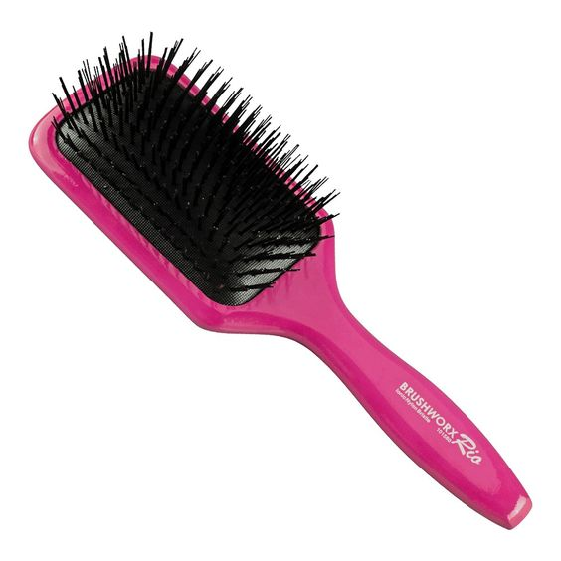
13) What were two mistakes that the killer made in the crime?

1 - ___________________________________________________________________________

2 - ________________________________________________________________________________

VIDEO FOLLOW-UP WRITING
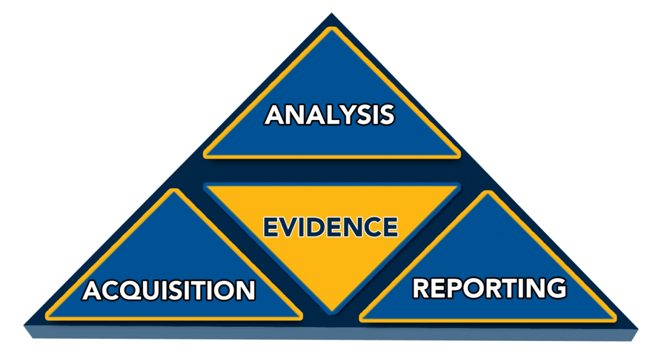
DESCRIPTION
Explain three important pieces of evidence in this case.
Which do you feel was most important?

_________________________________________________________________________________

_______________________________________________________________________________________

_______________________________________________________________________________________

_______________________________________________________________________________________

_______________________________________________________________________________________

_______________________________________________________________________________________

_______________________________________________________________________________________

_______________________________________________________________________________________

_______________________________________________________________________________________

_______________________________________________________________________________________

_______________________________________________________________________________________

_______________________________________________________________________________________

_______________________________________________________________________________________

PROBLEM / SOLUTION
Explain a problem police faced in this case and how forensics helped them solve it.

_________________________________________________________________________________

_______________________________________________________________________________________

_______________________________________________________________________________________

_______________________________________________________________________________________

_______________________________________________________________________________________

_______________________________________________________________________________________

_______________________________________________________________________________________

_______________________________________________________________________________________

_______________________________________________________________________________________

_______________________________________________________________________________________

